**Name**: Amr Adel El-Sayed El-Naqeeb

**B.N:** 14

**Date: 10/6/2021**

**Topic:** Programming Languages (PL)

**Application Brief**: I Could not find a better topic than programming languages as, in many universities, it is important to write and learn about the current mainstream languages C, C++, C#, or Java.

**Screenshots**

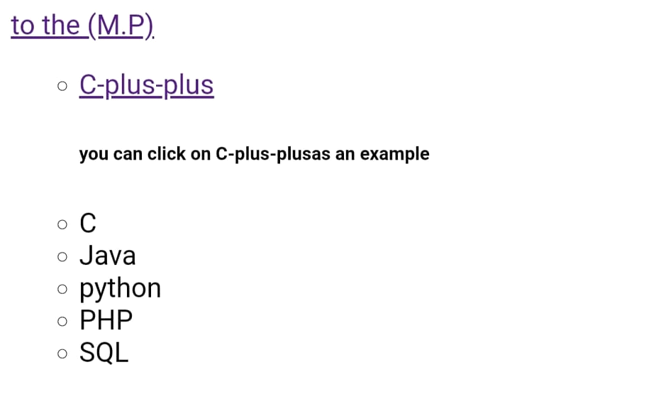

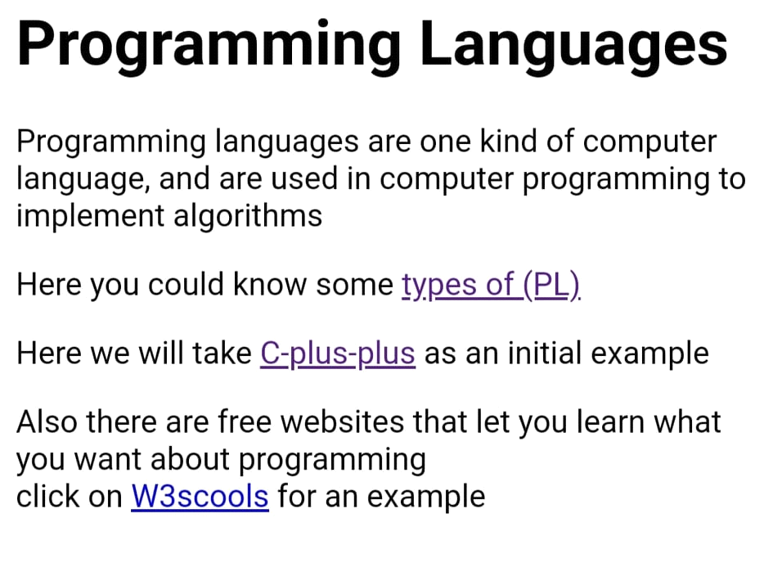



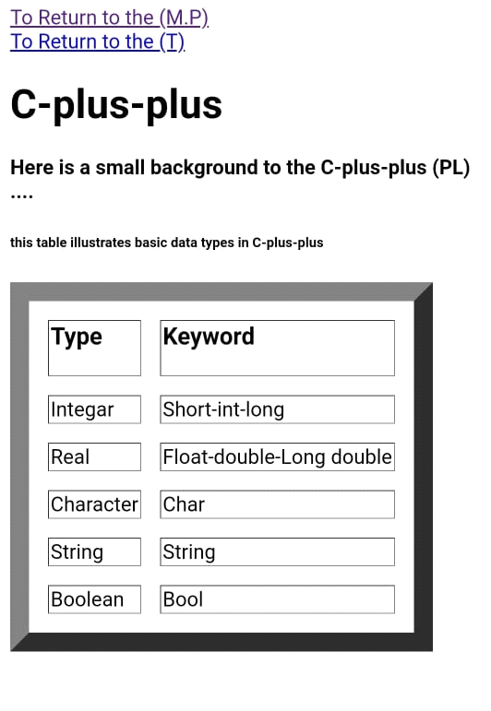

**Source Codes:**

